4.7 Write a program to print fibonacci series upto n numbers.
#include<stdio.h>
int main()
{int n,i,a=0 , b=1 ,sum;
printf("enter no. of terms");
scanf("%d",&n);
printf("output is - \n");
for(i=0 ; i<=n ; i++)
{
printf("%d \n" , a);
sum=a+b;
a=b;
b=sum;
}
return 0;
}
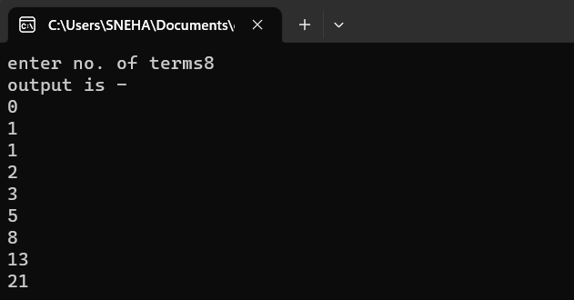
4.8 Write a program to show the use of break statement .
#include<stdio.h>
#include<conio.h>
int main()
{int i,n;
printf("ENTER NUMBER - ");
scanf("%d",&n);
for (i=1; i<=n; i++)
{
if (i==5)
{ break;
}
printf("%d\n",i);
}
return 0;
}

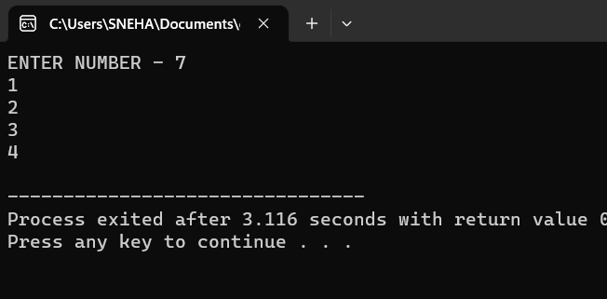

PRACTICAL :5 1D ARRAYS
5.1 WRITE A PROGRM TO READ AND DISPLAY 1D ARRAY.
# include<stdio.h>
# include<conio.h>
int main()
{
int a[10],i;
printf("enter element of array");
for(i=0;i<10;i++)
{scanf("%d\n",&a[i]);
}
printf("elements are");
for(i=0;i<10;i++)
{
printf("%d\n",a[i]);
}
return 0;
}
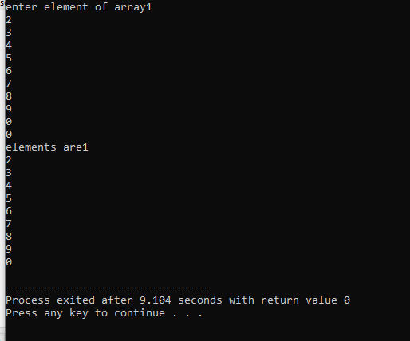

PRACTICAL 6 : 2D ARRAY AND STRING
6.1 WRITE A PROGRAM TO READ AND DISPLAY 2D ARRAY.
# include <stdio.h>
# include <conio.h>
int main()
{
int a[5][2],i,j;
printf("enter elements");
for(i=0;i<5;i++)
{
for(j=0;j<2;j++)
{scanf("%d",&a [i][j]);
}
printf("\n");
}
printf("elements are");
for(i=0;i<5;i++)
{
for(j=0;j<2;j++)
{
printf("%d",a [i][j]); }
}
printf("\n");

return 0;
}

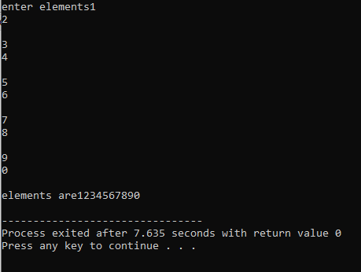
6.2 WRITE A PROGRAM TO ADD TWO MATRICES.
# include <stdio.h>
# include <conio.h>
int main()
{
int a[3][3],i,j,b[3][3],c[3][3];
printf("enter elements for first matrix");
for(i=0;i<3;i++)
{
for(j=0;j<3;j++)
{ scanf("%d\t",&a[i][j]);}
}

printf("\n");

printf("enter elements for second matrix");
for(i=0;i<3;i++)
{
for(j=0;j<3;j++)
{
scanf("%d",&b[i][j]);}
}

for(i=0;i<3;i++){

for(j=0;j<3;j++){

c[i][j]=a[i][j]+b[i][j];
printf("%d",c[i][j]);
}

printf("\n");

}
return 0;
}
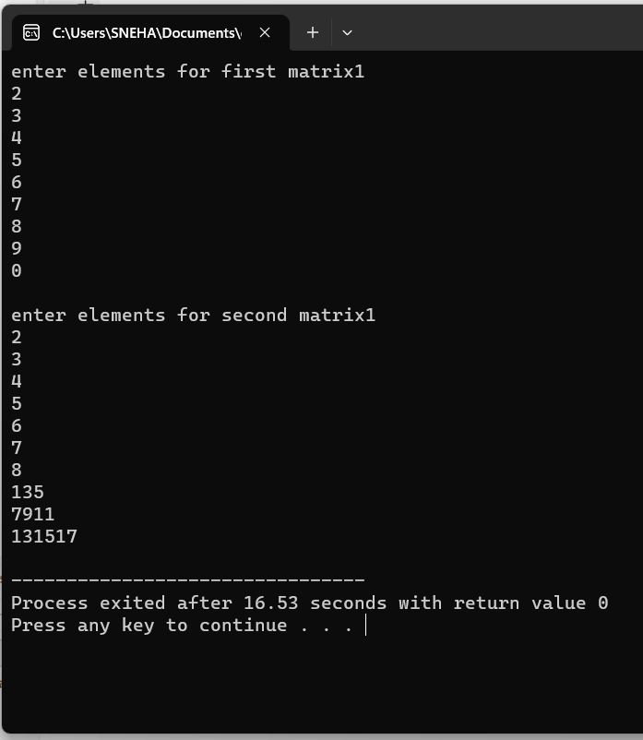

6.3 WRITE A PROGRAM TO PRINT FOLLOWING PATTERNS.
(I)
*
**
***
****

# include<stdio.h>
int main()
{int i,j;
for(i=1;i<=5;i++)
{
for(j=1;j<i;j++)
{
printf("*");

}
printf("\n");
}
return 0;
}
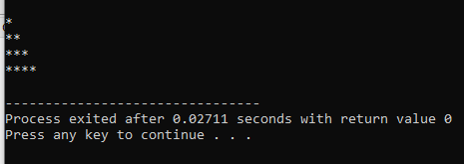
(2)
****
***
**
*
# include<stdio.h>
int main()
{int i,j;
for(i=4;i>=1;i--)
{
for(j=1;j<=i;j++)
{
printf("*");

}
printf("\n");
}
return 0;
}
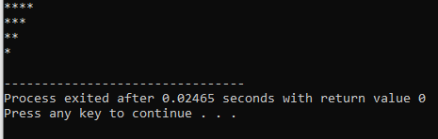
(3)
1
12
123
1234

# include<stdio.h>
int main()
{int i,j;
for(i=0;i<=4;i++)
{
for(j=1;j<=i;j++)
{
printf("%d",j);

}
printf("\n");
}
return 0;
}
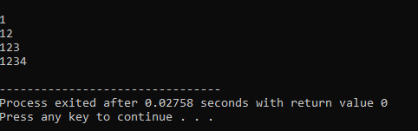
(4)
1
22
333
4444
# include<stdio.h>
int main()
{int i,j;
for(i=0;i<=4;i++)
{
for(j=1;j<=i;j++)
{
printf("%d",i);

}
printf("\n");
}
return 0;
}
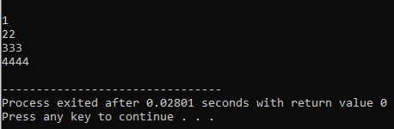
6.4 WRITE A PROGRAM TO READ AND DISPLAY STRING.
# include<stdio.h>
# include<string.h>
int main()
{
char s[20];
printf("enter a string");
gets(s);
printf("enter string is %s",s); //puts(s);
return 0;
}
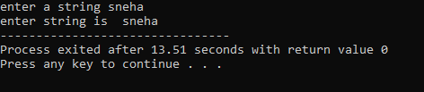
6.5 WRITE A PROGRAM TO FIND LENGTH OF A STRING.
# include<stdio.h>
# include<string.h>
int main()
{
char s1[10]="HELLO";
int x=strlen(s1);

printf("length is:%d",x);

return 0;
}
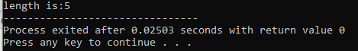
6.6 WRITE A PROGRAM TO REVERSE A STRING.
# include<stdio.h>
# include<string.h>
int main()
{
char s1[10]=”KAMNA”;

printf("reverse string is:%s",strrev(s1));

return 0;
}
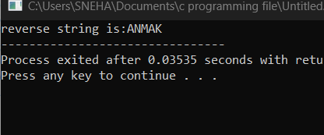

6.7 WRITE A PROGRAM TO CONVERT A STRING INTO LOWERCASE.
# include<stdio.h>
# include<string.h>
int main()
{
char s1[10];
printf("enter a string");
gets(s1);
printf("STRING IN LOWERCASE IS:%s",strlwr(s1));

return 0;
}
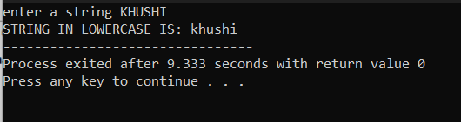
6.8 WRITE A PROGRAM TO CONVERT A STRING INTO UPPER CASE.
# include<stdio.h>
# include<string.h>
int main()
{
char s1[10];
printf("enter a string");
gets(s1);
printf("STRING IN UPPERCASE IS:%s",strupr(s1));

return 0;
}
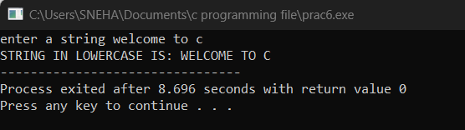
6.9 WRITE A PROGRAM TO COPY A STRING.
# include<stdio.h>
# include<string.h>
int main()
{
char s1[10]="wow",s2[10];
strcpy(s2,s1);
printf("copied string is :%s",s2);
return 0;
}
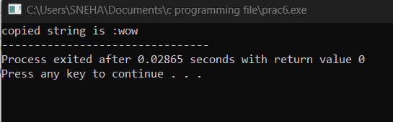
6.10 WRITE A PROGRAM TO CONCATE TWO STRINGS.
# include<stdio.h>
# include<string.h>
int main()
{
char s1[10]="PUNJAB",s2[10]="UNIVERSITY";
strcat(s1,s2);
printf("new string is :%s",s1);
return 0;
}
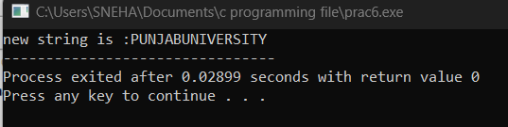
6.11 WRITE A PROGRAM TO CHECK TWO STRINGS ARE EQUAL.
# include<stdio.h>
# include<string.h>
int main()
{
char s1[10]="PUNJAB",s2[10]="PUNJAB";
if(strcmp(s1,s2)==0)
{
printf("strings are equal");
}
else

{
printf("strings are not equal");

}

return 0;
}
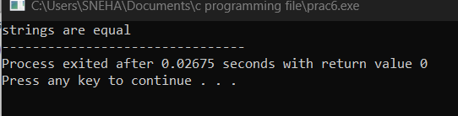

PRACTICAL 7: FUNCTIONS
7.1 WRITE A PROGRAM TO ADD TWO NUMBERS USING NO PARAMETER NO RETURN VALUE.
# include<stdio.h>
int main()
{
void sum();
sum();
return 0;
}
void sum()
{
int a ,b,c;
printf("enter rwo numbers");
scanf("%d%d",&a,&b);
c=a+b;
printf("sum is %d",c);

}
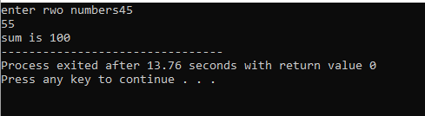
7.2 WRITE A PROGRAM TO ADD TWO NUMBERS USING WITH PARAMETER NO RETURN VALUE.
# include<stdio.h>
int main()
{ int a,b;
void sum(int,int);
printf("enter two numbers");
scanf("%d%d",&a,&b);
sum(a,b);
return 0;
}
void sum(int x,int y)
{
int z;
z=x+y;

printf("value is :%d",z);
}
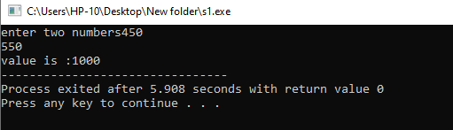
7.3 WRITE A PROGRAM TO ADD TWO NUMBERS USING NO PARAMETER WITH RETURN VALUE.
# include<stdio.h>
int main()
{ int r;
int sum();
r=sum();
printf("sum is %d",r);
return 0;
}
int sum()
{int a,b,c;
printf("enter two numbers");
scanf("%d%d",&a,&b);
c=a+b;
return c;
}
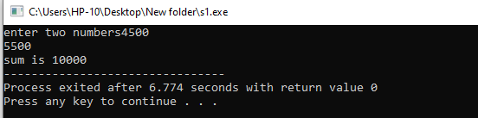
7.4 WRITE A PROGRAM TO ADD TWO NUMBERS USING WITH PARAMETER WITH RETURN VALUE.
# include <stdio.h>
int add (int a,int b)
{ int c;
c=a+b;
return c;
}
int main()
{int x,y,z;
printf("enter two numbers");
scanf("%d%d",&x,&y);
z=add(x,y);
printf("\n addition is:%d",z);
return 0;
}
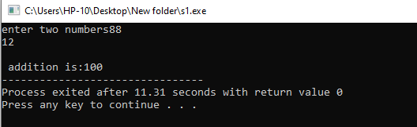
7.5 WRITE A PROGRAM TO SWAP TWO NUMBERS USING CALL BY VALUE.
# include <stdio.h>
void swap(int a,int b);
int main()
{ int x=3,y=5;
swap(x,y);
printf("x=%d & y=%d",x,y);
return 0;
}
// call by value
void swap(int a,int b){
int t=a;
a=b;
b=t;
printf("a = %d & b=%d",a,b);
}
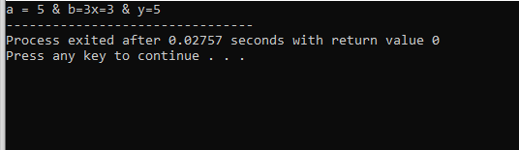
7.6 WRITE A PROGRAM TO SWAP TWO NUMBERS USING CALL BY REFERENCE.
# include <stdio.h>
void swap(int*a,int*b )
{
int c;
c=*a;
*a=*b;
*b=c;
}
int main()
{int x,y;
printf("enter two numbers");
scanf("%d%d",&x,&y);
printf("\n value before swap :%d\n%d",x,y);
swap(&x,&y);
printf("\n value after swap:%d\n%d",x,y);
return 0;
}
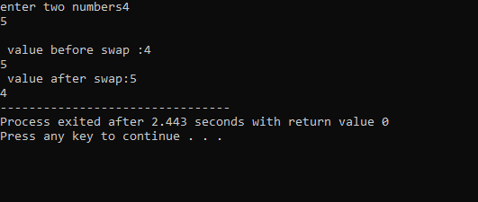
7.7 WRITE A PROGRAM TO FIND FACTORIAL OF A NUMBER USING RECURSION.
# include <stdio.h>
int factorial(int n)
{if(n<=1)
{return 1;
}
else
{
return n*factorial(n-1);
}
}
int main()
{int a,fact;
printf("enter any number");
scanf("%d",&a);
fact=factorial(a);
printf("factorial is %d",fact);
return 0;

}
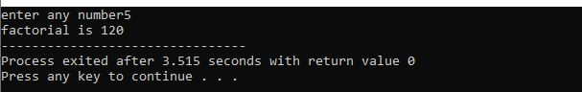
7.8 WRITE A PROGRAM TO FIND FIBONACCI SERIES USING RECURSION.
# include<stdio.h>
int fib(int n);
int main()
{

fib(6);
return 0;
}
int fib(int n)
{ if (n==0||n==1)
if(n==0)
{return 0;
}
else if(n==1)
{return 1;
}
int fibnm1=fib(n-1);
int fibnm2=fib(n-2);
int fibnm=fibnm1+fibnm2;
printf("fib of %d is:%d\n",n,fibnm);
return fibnm;
}
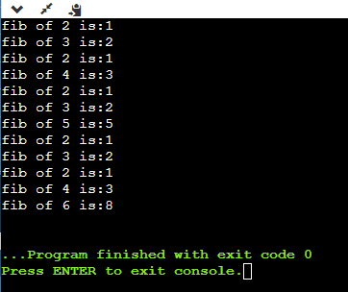

PRACTICAL 8: PROGRAMMING FOR SOLVING NUMERICAL METHOD PROBLEMS.

8.1 WRITE A PROGRAM TO FIND ROOTS OF QUADRATIC EQUATION.
# include <stdio.h>
# include <math.h>
int main(){

float a,b,c,R1,R2,D;
printf("enter values for a b c");
scanf("%f%f%f",&a,&b,&c);
D=b*b-4*a*c;
if (D>0){

R1=(-b+sqrt(D))/2*a;
R2=(-b-sqrt(D))/2*a;
printf("the real roots are:%f\n%f",R1,R2);
}
else if(D==0)
{

R1=-b/(2*a);
R2=-b/(2*a);
printf("roots are equal:%f\n%f",R1,R2);}

else
printf("roots are imaginary");
return 0;
}
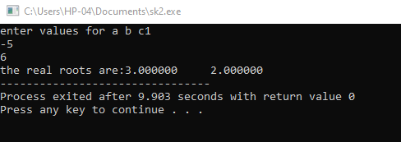

PRACTICAL 9: STRUCTURES
9.1 WRITE A PROGRAM TO READ AND DISPLAY STUDENT DATA USING STRUCTURE.
# include <stdio.h>
# include <string.h>
struct student
{int roll;
char name [10];
float marks;
};
int main()
{struct student s1;
s1.roll=1073;
strcpy(s1.name,"AMBRISH");
s1.marks=96;
printf("roll no is :%d",s1.roll);
printf("\n name is :%s",s1.name);
printf(" \n marks is: %f",s1.marks);
return 0;
}
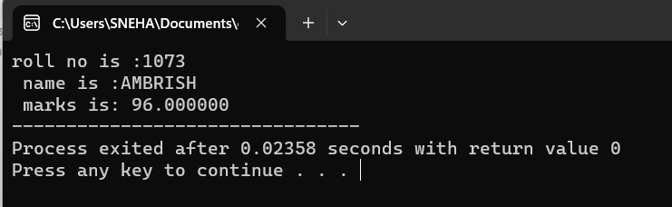
9.2 WRITE A PROGRAM TO ENTER AND DISPLAY THE DATA OF 10 STUDENTS.
# include<stdio.h>
# include<string.h>
struct student
{
int roll;
char Name[25];

int Age;
float marks;
};
int main()
{
int i;
struct student s1[10];
for(i=1;i<=10;i++)
{

printf("\nEnter details of student");

printf("\n\t Enter student roll : ");
scanf("%d",&s1[i].roll);

printf("\n\t Enter student Name : ");
scanf("%s",&s1[i].Name[25]);

printf("\n\tEnter student age:");
scanf("%d",&s1[i].Age);

printf("\n\tEnter student marks : ");
scanf("%f",&s1[i].marks);}

{
printf("\nDetails of student");
for(i=1;i<=10;i++)}
{
printf("\n%d\t%s\t%d\t%f",s1[i].roll,s1[i].Name[25],s1[i].Age,s1[i].marks);
return 0;}

}
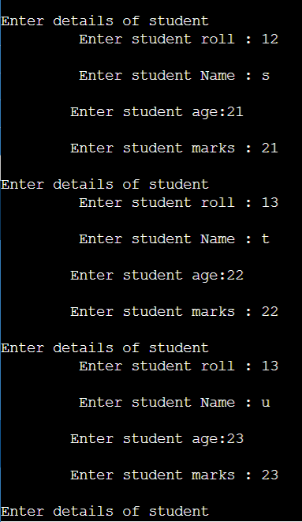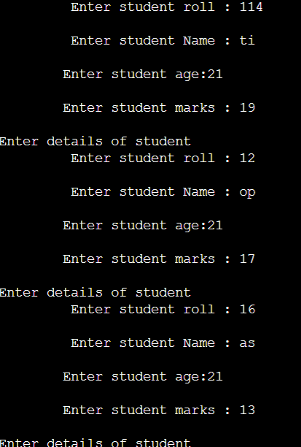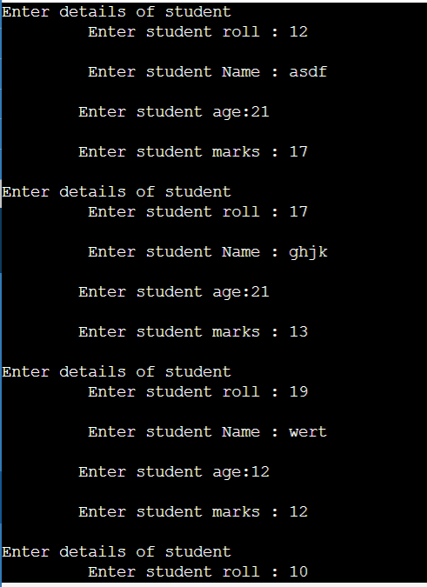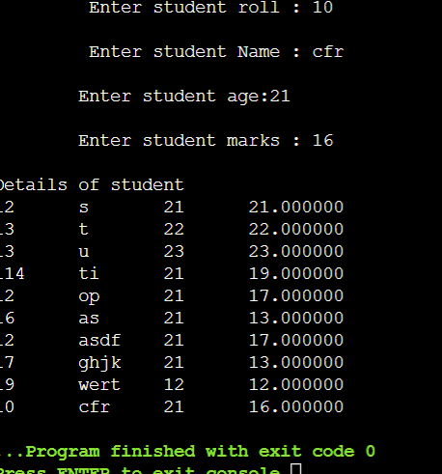
9.3 WRITE A PROGRAM TO SHOW THE USE OF NESTED STRUCTURE.
# include<stdio.h>
# include<string.h>
struct dob
{int day;
int month;
int year;
};
struct student
{
int roll;
char Name[25];
int Age;
float marks;
struct dob d1;
};
int main()
{
struct student s;

printf("\nEnter details of student");
scanf("%d%s%d%f%d%d%d",&s.roll,&s.Name,&s.Age,&s.marks,&s.d1.day,&s.d1.month,&s.d1.year);

printf("\n%d\t%s\t%d\t%f\t%d\t%d\t%d",s.roll,s.Name,s.Age,s.marks,s.d1.day,s.d1.month,s.d1.year);

return 0;}
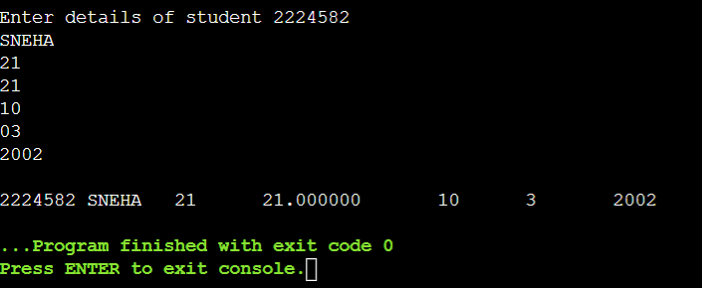

PRACTICAL 10 : UNION
10.1 WRITE A PROGRAM TO ENTER AND DISPLAY STUDENT DATA USING UNION.
# include<stdio.h>
# include<conio.h>
union student
{
int roll;
char Name[25];
int Age;
float marks;
}s;
int main()
{
printf("\nEnter details of student");
printf("\nEnter student roll: ");
scanf("%d",&s.roll);
printf("roll:%d",s.roll);

printf("\nEnter student Name : ");
scanf("%s",&s.Name);
printf("Name:%s",s.Name);
printf("\nEnter student Age : ");
scanf("%d",&s.Age);
printf("Age:%d",s.Age);
printf("Enter student marks:") ;
scanf("%f",&s.marks) ;
printf("marks:%f",s.marks) ;
return 0;
}
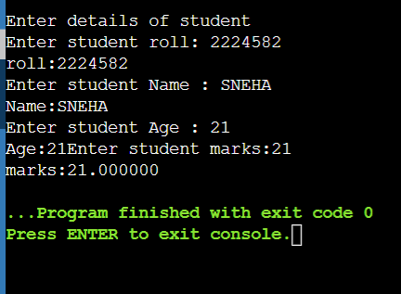

PRACTICAL 11: POINTERS
11.1 WRITE A PROGRAM TO SHOW THE USE OF POINTER
#include<stdio.h>
#include<conio.h>
int main()
{
int a;
int *p;
clrscr();
p=&a;
printf("enter any number");
scanf("%d",&a);
printf("\n address is %p",a);
printf("\n value is %d",*p);
getch();
return 0;
}
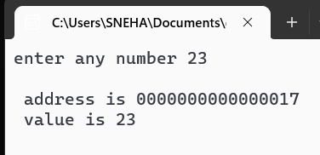
11.2 WRITE A PROGRAM TO SHOW THE USE OF ARRAY AS POINTER
#include<stdio.h>
#include<conio.h>
int main()
{
int var[]={40,50,60};
int i,*ptr[3];

for(i=0;i<3;i++)
{
ptr[i]=&var[i];
}
for(i=0;i<3;i++)
{
printf("\n value is %d",*ptr[i]);
}
getch();
return 0;

}
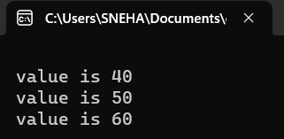
11.3: WRITE A PROGRAM TO SHOW THE USE OF POINTER TO POINTER
#include<stdio.h>
#include<conio.h>
int main()
{
int a;
int *ptr1;
int **ptr2;
ptr1=&a;
ptr2 = &ptr1;

printf("enter any number");
scanf("%d",&a);
printf("\n address of first pointer is %p",ptr1);
printf("\n address of second pointer is %p",ptr2);
printf("\n value for first pointer is %d",*ptr1);
printf("\n value for second pointer is %d",**ptr2);
getch();
return 0;
}
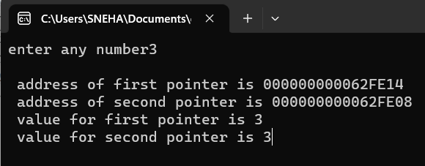
11.4 WRITE A PROGRAM TO SHOW THE USE OF DYNAMIC MEMORY ALLOCATION USING POINTERS
#include<stdio.h>
#include<conio.h>
#include<stdlib.h>
int main()
{
char *p;

p= malloc(80);
if(p==NULL)
{
printf("memory allocation failed");
exit(1);
}
printf("enter a string");
gets(p);
printf(p);
free(p);
getch();
return 0;

}
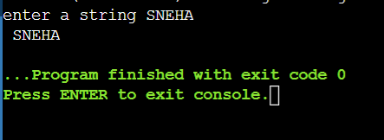
PRACTICAL 12: FILE HANDLING
12.1 WRITE A PROGRAM TO READ A FILE
#include<stdio.h>
#include<conio.h>
#include<stdlib.h>
int main()
{
char c;
FILE *p;
p=fopen("C:\\Users\\SNEHA\\Desktop\\Document.txt","r");
if(p==NULL)
{
puts("file cannot be opened");
exit(1);
}
while((c=fgetc(p))!=EOF)
{
printf("%c",c);
}
fclose(p);
getch();
return 0;
}
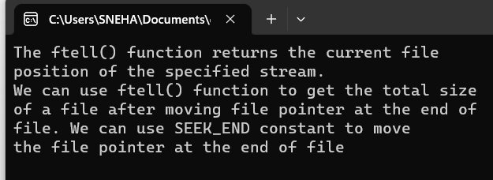
12.2 WRITE APROGRAM TO WRITE A CHARACTER IN A FILE
#include<stdio.h>
#include<conio.h>
int main()
{
char c;
FILE *p;
p=fopen("C:\\Users\\SNEHA\\Desktop\\Document.txt","w");
for(c='a';c<='z';c++)
{
putc(c,p);
}
fclose(p);
getch();
return 0;
}
